USER MANUAL

ARCENM: AUGMENTED REALITY - BASED CAMPUS EXPLORATION AND NAVIGATION MAP
The ARCENM Application was made exclusively for Southern Luzon State University - Tayabas Campus. The application contains augmented 3D Maps with current location of the user and other digital accessible information of the campus using QR codes. The purpose of this application is to navigate different locations of the campus for self-paced campus exploration and to view digitally the availability of campus accessible informations such us; SLSU Profile, SLSU Timeline, School Application Requirements, SLSU Library E-Resources and more.
Note: The application can be use with or without an internet connection.

WITH INTERNET CONNECTION
- To visit facebook pages, emails, and websites in the application through buttons.
WITHOUT INTERNET CONNECTION
- The whole application can operate without an internet connection.
- The scanner can be use as well.
Step 1: Open the application.


- Startup interface will appear
- Next, the main menu shows up, it has 3 buttons.
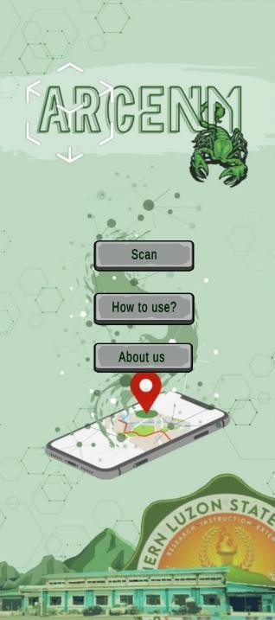
Scan Button:
- Once tap, it requires QR code, afterwards it will display digital
elements.
How to use Button:
- Concise user manual attached here.
About us Button:
- Contains information about the developers.
MAIN MENU

Step 2: Tap the how to use button to view the concise user manual.
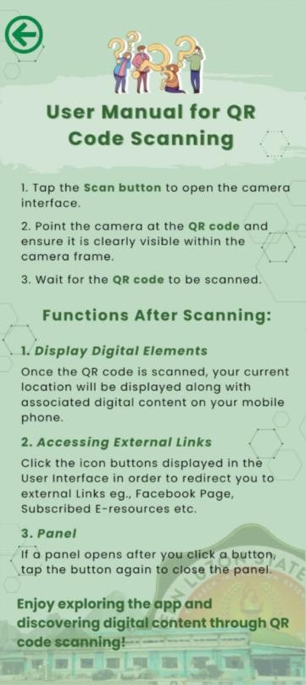
Step 3: You can also tap the about us button to view the information about the developers.
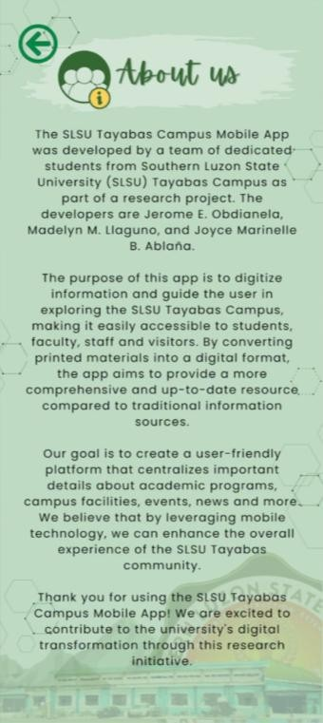

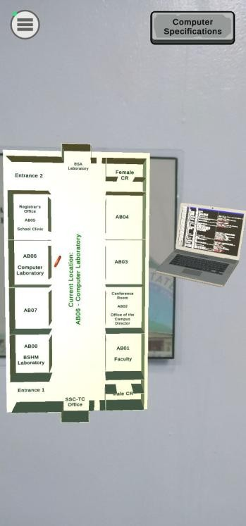
Step 4: If you learned how to use the application.
- Tap the scan button, wait for a moment to open the camera
interface for QR code scanning.
- Then, scan the QR code and it will display digital elements.

Back to Main Menu Button

Sample of digital element:
Augmented 3D Map
with user’s current location.
Step 5: Navigate the other markers, and enjoy exploring the campus.
  - The QR codes are placed to various locations in the campus.
EARTH Building 1 (2nd Floor)
Academic Building 2

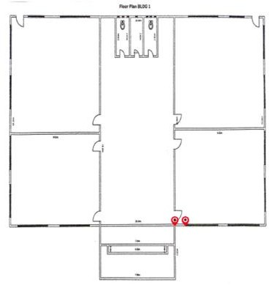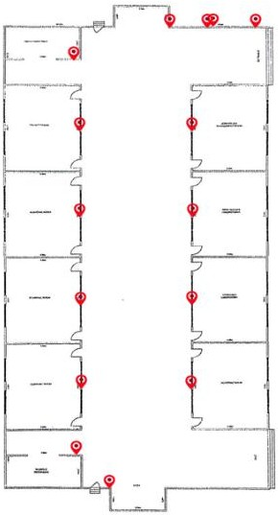
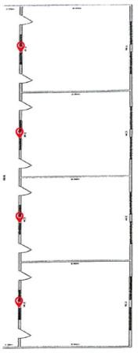
LICUP Building 3

QR Code Sample:
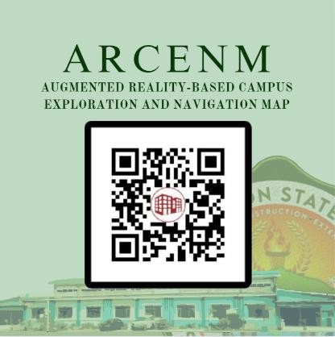
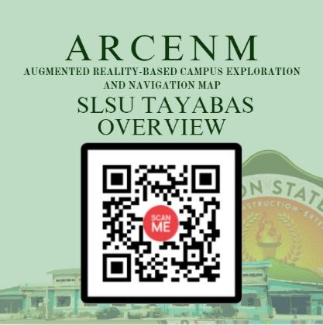
FUNCTIONS AFTER SCANNING:

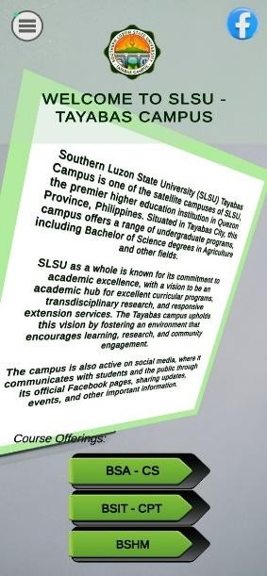
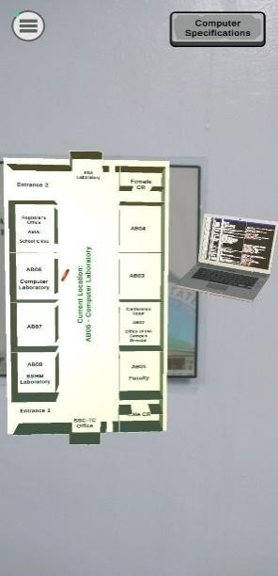
Display Digital Elements
1.
    - Once the QR code is scanned, your current location will be displayed along with
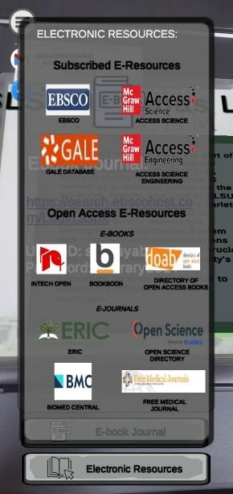
associated digital content on your mobile phone.

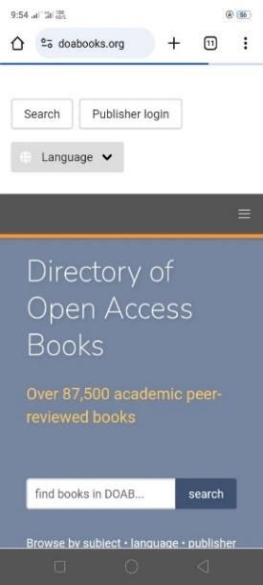
Accessing External Links
2.
    - Click the icon buttons displayed in the User Interface in order to redirect you to external links eg., Facebook Page, Subscribed E-
resources etc.

